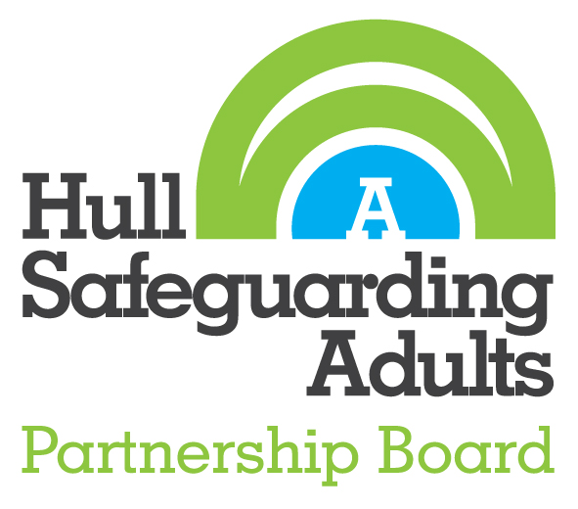

Safeguarding Adult Review Referral Form

Hull Safeguarding Adults Partnership Board (HSAPB) Safeguarding Adult Review Panel (SAR Panel) considers a referral based on whether it meets the criteria for a Safeguarding Adult Review (SAR).

[Section 44 of the Care Act 2014](https://www.legislation.gov.uk/ukpga/2014/23/section/44) specifies when a SAR must be held.

|  |
| --- |
| Criteria for Conducting a SAR |
| A SAR is not restricted to occasions where the safeguarding procedures have been followed and can be applied where this has not been the case. Adoption of the SAR process will be relevant to circumstances where inter-agency working practices have not served to effectively protect the adult(s) at risk from harm or the risk of serious harm.  The HSAPB will consider undertaking a SAR when it is known or suspected that:  (i) Actions or omissions in a number of agencies involved in the provision of care, support or safeguarding of an adult, or group of adults, at risk of abuse or neglect have caused or are implicated in the death or serious harm of that individual or group of individuals.  or  (ii) An adult or group of adults at risk die or experience serious harm and there are concerns about how agencies have worked together to prevent, identify, minimise or address that harm and there are concerns about how this may place other adults at risk of serious harm;  and  (iii) There are clearly identified areas of learning and practice improvement or service development that have the potential to significantly improve the way in which adults at risk of abuse and neglect are safeguarded in the future.  The SAR Panel will consider the issues raised and will examine the potential for learning across agencies/services. When a case meets the criteria for a SAR, the HSAPB SAR Panel will seek to identify what other reviews and processes are taking place or envisaged in relation to the same events, such as:   * Child Serious Case Review * Domestic Homicide Review   There will be early liaison with the decision-maker in any related review process to determine how the reviews can be effectively managed to maximise learning for individuals and agencies, and to avoid duplication for families and professionals.  Consideration will be given to -   * Whether the actions of all agencies and all aspects of the case could be effectively covered by one of the reviews * Whether it would be appropriate for related reviews to be chaired by the same person * Whether some aspects of related reviews could be commissioned or undertaken jointly * Ensuring that the terms of reference for related reviews effectively cover all aspects of the case   Early consideration will also be given to the way the SAR will take account of other possible connected processes, such as -   * Police investigation/criminal charges * Health and Safety Executive investigation/charges * Coroner’s inquest   The SAR process does not replace any existing single agency internal review or process, complaint or legal process. These processes should continue as intended unless there is a clear rationale why the outcome of the SAR would affect this.  Consideration will also be given to how to engage with adults, families and/or advocates to enable involvement and contribution to reviews, and how their expectations can be managed appropriately and sensitively. |

|  |
| --- |
| Completing this referral |
| Always use an appropriate confidential e mail system when sending the completed form. |
| Include only information which is known about the adult at risk and the alleged perpetrator (s). Do not make assumptions about either the adult at risk or the alleged perpetrator(s). |
| When describing the incident use factual details only. Describe the circumstances of the incident as you know them. Do not use overly emotive or critical language. Do not attempt to blame people or agencies for what you think may have caused the incident – the review is about looking at what happened to bring out any missed opportunities and the learning from these. |
| Use plain language that can be understood by someone with no prior knowledge of your agency and provide the meaning of any acronyms. Do not copy and paste extensive pieces of information from your agency’s records and/or chronologies. |
| What are the care and support needs as identified in the Care Act 2014?   * The adult’s needs arise from or are related to a physical or mental impairment or illness * As a result of the adult’s needs, the adult is unable to achieve two or more of the outcomes specified below:  1. Managing and maintaining nutrition 2. Maintaining personal hygiene 3. Managing toilet needs 4. Being appropriately clothed 5. Being able to make use of the adults home safely 6. Maintaining a habitable home environment 7. Developing and maintaining family or other personal relationship 8. Accessing and engaging in work, training, education, or volunteering 9. Making use of necessary facilities or services in the local community, including public transport, and recreational facilities or services 10. Carrying out any caring responsibilities the adult has for a child   As a consequence, there is, or is likely to be, a significant impact on the adult’s well-being. |
| If you have any questions, contact the HSAPB Senior Safeguarding Officer on 01482 615415 or [safeguardingadultsboard@hullcc.gov.uk](mailto:safeguardingadultsboard@hullcc.gov.uk) |
| Further information about Safeguarding Adult Reviews can be found on the HSAPB web site  [Hull Safeguarding Adults Partnership Board - Policies and procedures – Hull Collaborative Partnership](https://www.hullcollaborativepartnership.org.uk/downloads/download/14/hull-safeguarding-adults-partnership-board---policies-and-procedures) |

|  |  |
| --- | --- |
| 1.Referrer | |
| Name |  |
| Job title |  |
| Agency |  |
| Address |  |
| Telephone number |  |
| Email address |  |
| Role or relationship to adult in this referral |  |
| Date of referral |  |

|  |  |
| --- | --- |
| 2.Senior Manager Authorisation | |
| Name |  |
| Job title |  |
| Telephone number |  |
| Address |  |
| Email address |  |
| Date referral authorised |  |

|  |  |
| --- | --- |
| 3. Details of the adult subject of this referral | |
| Name |  |
| Date of birth |  |
| Gender |  |
| Ethnicity |  |
| Address |  |
| Has the adult died | Yes/No |
| Date of death (where applicable) |  |
| Date of incident(s) if still alive |  |
| GP name and address (if known) |  |
| NHS number (if known) |  |
| Details of any medical conditions (Physical and mental) |  |
| Details of care and support needs |  |
| Was the adult open to Adult Social Care? | Yes/No |
| Did the adult have a carer or advocate? | Yes/No |

|  |  |
| --- | --- |
| 4. Details of the representative/family of the adult with care and support needs | |
| Does the adult have any family or representative? | Yes/No |
| Are they aware of the SAR referral? | Yes/No |
| Family member/representative contact name |  |
| Relationship to the adult |  |
| Address |  |
| Telephone number |  |
| E mail address |  |

|  |  |
| --- | --- |
| 5. Person(s) or Agency(s) Alleged Responsible to have Caused Harm or Neglect | |
| Name |  |
| Agency |  |
| Date of Birth (where applicable): |  |
| Address: |  |
| Relationship with adult (where applicable): |  |

|  |  |
| --- | --- |
| 6. How does this referral meet the SAR criteria? | |
| Refer to the information at the start of this referral form for further details of what circumstances are likely to meet the criteria for a SAR. | |
| What type of abuse or neglect is the adult known or suspected to have suffered | ☐ Physical ☐ Sexual  ☐ Psychological or emotional ☐ Self-neglect  ☐ Financial ☐ Modern slavery  ☐ Domestic abuse ☐ Organisational  ☐ Neglect or acts of omission ☐ Discriminatory  ☐ Other Please specify) |
| Date of incident and cause of death (if applicable)  Provide information as to why you know or have reason to suspect a direct causal link between the death or harm caused and an instance of abuse or neglect? |  |
| Did the adult have care and support needs?  Care and support needs relate to help needed by an adult to manage and remain independent, arising from issues of learning or physical disability, mental illness or substance misuse. A care package does not need to be in place (Care Act 2014)  [Quick guide to eligibility outcomes under the Care Act 2014 - SCIE](https://www.scie.org.uk/assessment-and-eligibility/determination-eligibility/eligibility-outcomes/) |  |
| Why you consider there to be concerns about the way in which several agencies worked together to safeguard the adult.  Provide information that suggests the case has highlighted that several agencies have not worked together effectively to protect the adult. If only one sector or one agency’s practice raises concern, then a single agency may be asked to undertake a review of the case. |  |

|  |  |
| --- | --- |
| 7. Investigations | |
| Section 42 adult safeguarding enquiry? | Yes/No/Completed  Outcome (if appropriate) |
| What other learning/review processes have been followed?  If so:   * What did they achieve? * How has the learning been disseminated? * What impact has it had? |  |
| Are there on-going criminal proceedings? |  |
| Are any parallel processes ongoing? |  |
| Other relevant information to support this referral |  |

|  |
| --- |
| 8. Other Person(s) or Agency(s) believed to have been involved with the adult. |
|  |
|  |
|  |
|  |

|  |
| --- |
| 9. If relevant provide details why this case may attract media attention |
|  |

|  |
| --- |
| 10. Other supporting information |
|  |

|  |  |
| --- | --- |
| 11. Referrer signature | |
| Signature: |  |
| Date: |  |

When completed, e mail this form to the HSAPB Senior Safeguarding Officer [safeguardingadultsboard@hullcc.gov.uk](mailto:safeguardingadultsboard@hullcc.gov.uk)